Explicit scheme formula

Dynamic equation
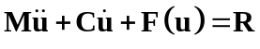 (1)
The time integration algorithm is
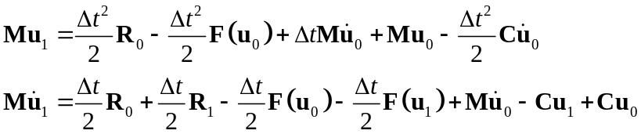 (2)
Another form of the time integration algorithm(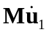) is
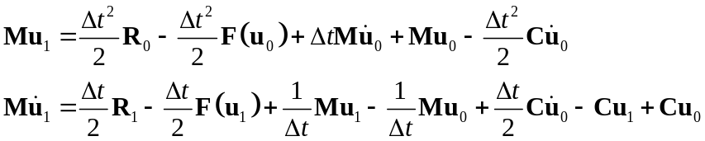 (3)

(5)

